# Chinook MVC Web App User Manual | B00884229 | Martin Alexander

## Read

**Home Page:**

**Albums Index Page**

Includes:

* Link to insert form page
* Search bar
* Drop down list to chose how to sort the albums
* Update and Delete buttons for each album record
* Album title are buttons that allow user to view album tracks

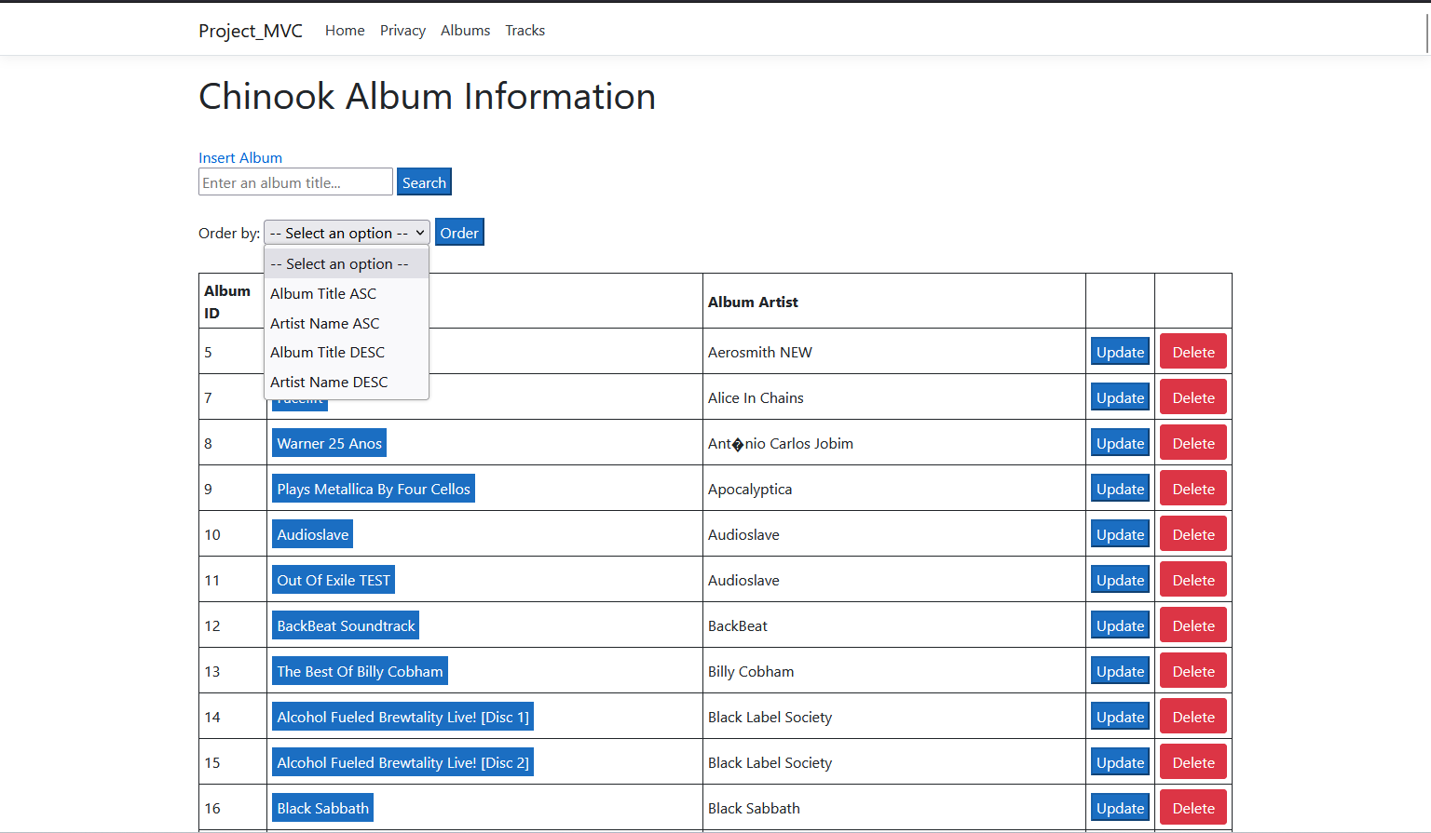

Clicking on the title of an album will take the user to the Tracks page will all the track names for the selected album.

There are four sorting options to choose from in the drop down list: Album Titles ASC or DESC and Artist Name ASC or DESC.

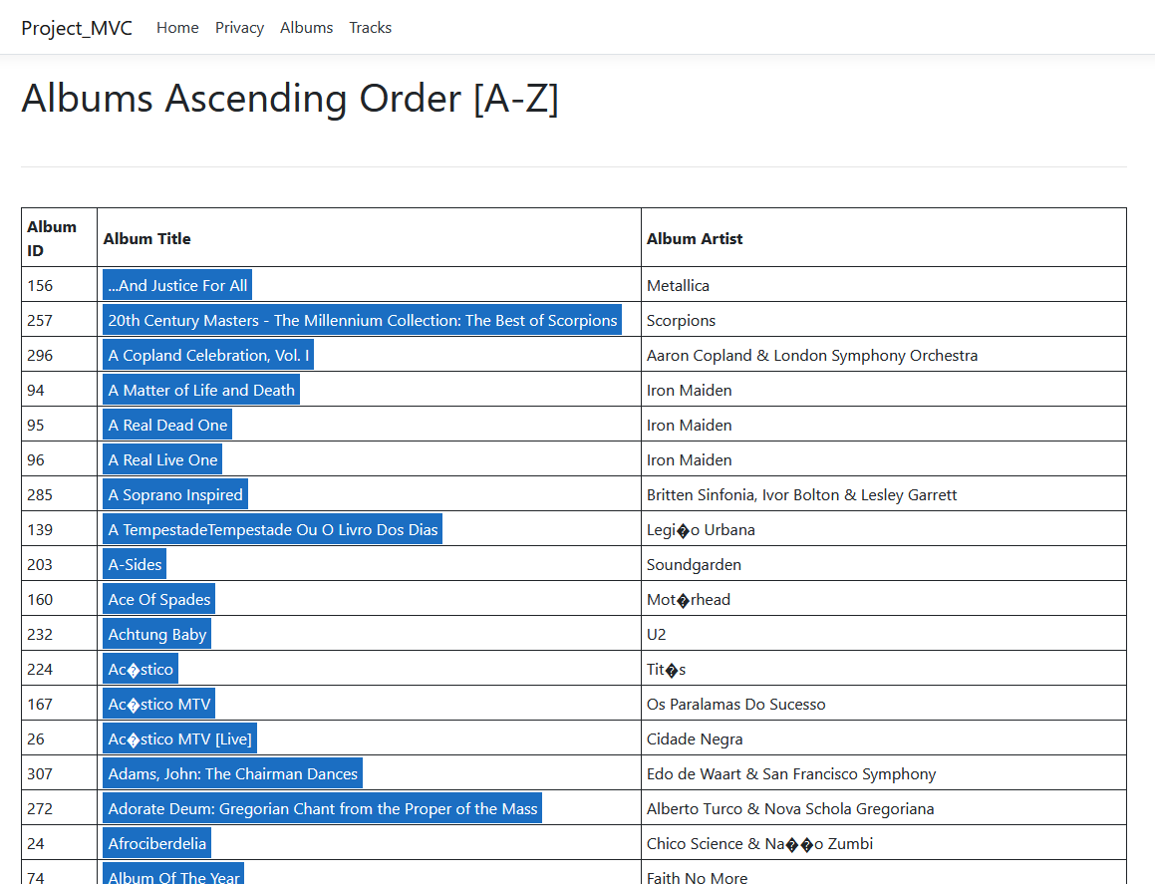

In this example, the text “Face” has been entered. The app queries the database to search for matching album titles or artist names that contain the text provided.

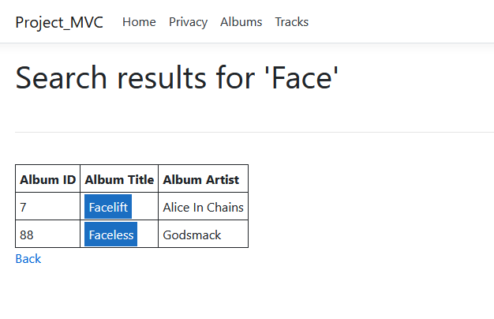

## Create

Clicking on the “Insert Album” link will take the user to the ‘Insert’ page This page allows the user to insert a new album by entering the album title, selecting the artist of the album from a drop down list (you can only choose from artists present in the database). There is also the functionality to choose the number of tracks in the album.

## Update

Clicking on the ‘Update’ button in the Albums Index page takes the user to the ‘updateForm’ page. This page will allow the user to update the album title, album artist or track names of the selected album. The user can also delete individual tracks or add more tracks to the album. Clicking the ‘Delete Track’ button will display a JavaScript popup to confirm the deletion action.

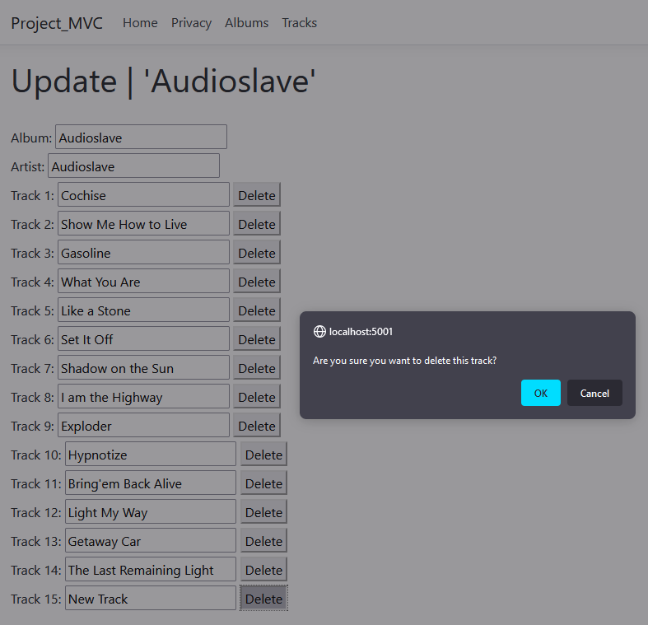

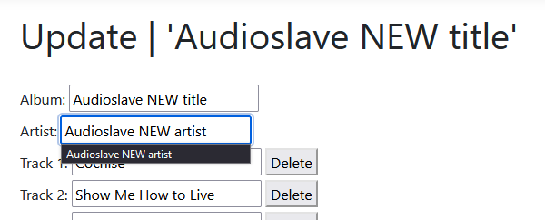



## Delete

Clicking the ‘Delete’ button on the Albums Index page will take the user to the ‘deletePage’ which displays the album title, album artist and all tracks in the album.

There are two buffers before the user can delete an album. The ‘deletePage’ acts as the initial buffer, and the JavaScript popup below is the final buffer. This is done to ensure the user doesn’t accidentally delete an album, as well as providing the user with ample time to make up their mind on whether the album should be deleted or not.

